Why Visual Storytelling is Powerful
Enhances Communication: Visuals allow for a richer, more engaging storytelling experience. It allows you to "show" rather than just tell.
Showing is all about conveying a message by letting the audience infer the intended meaning, rather than just hearing about it directly. This engages viewers deeply, as it means they are not just passive recipients of your information.
Engages Viewers: It captures attention and keeps viewers hooked, which is builds watch time, ethos, pathos and logos.
Builds Empathy and Emotion: Visuals help viewers feel the emotions being conveyed, enhancing the impact of the story.
Strengthens Personal Branding: Showcasing your environment and reactions through visuals creates a stronger connection with the audience.
Creates Memorable Content: Visual storytelling makes your content more memorable, aiding in viewer retention and recall.
Leverages the Full Potential of Video: Visuals use video's strengths to its fullest extent, which will explode your ethos, pathos, and logos.
What is B-Roll?
I'm going to refer to anything that goes on top of "A-roll" as "B-roll."
A-roll is your narrative, the backbone of the content, and B-roll is the footage that goes on top.
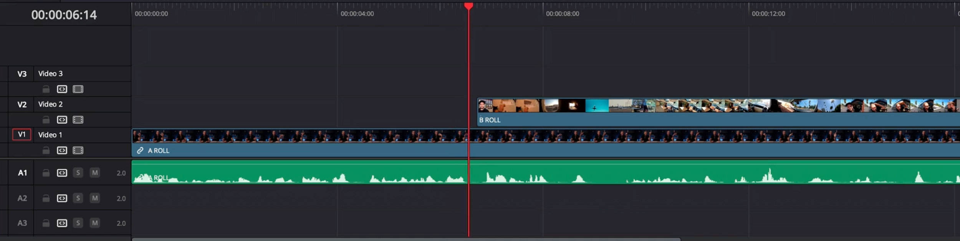
How to Level Up Your Videos with B-Roll
Stage 1: If you are new to filming B-roll, DO NOT try to shoot B-roll for your entire video.
Level up in sections and film some you use in the middle of your videos until you get faster at it and are able to tell better stories using it.
Ideally, we want to front-load B-roll into our intros, BUT if you're not able to pull this off yet, it could cause more harm than good, so practice on a section in the middle of your video.
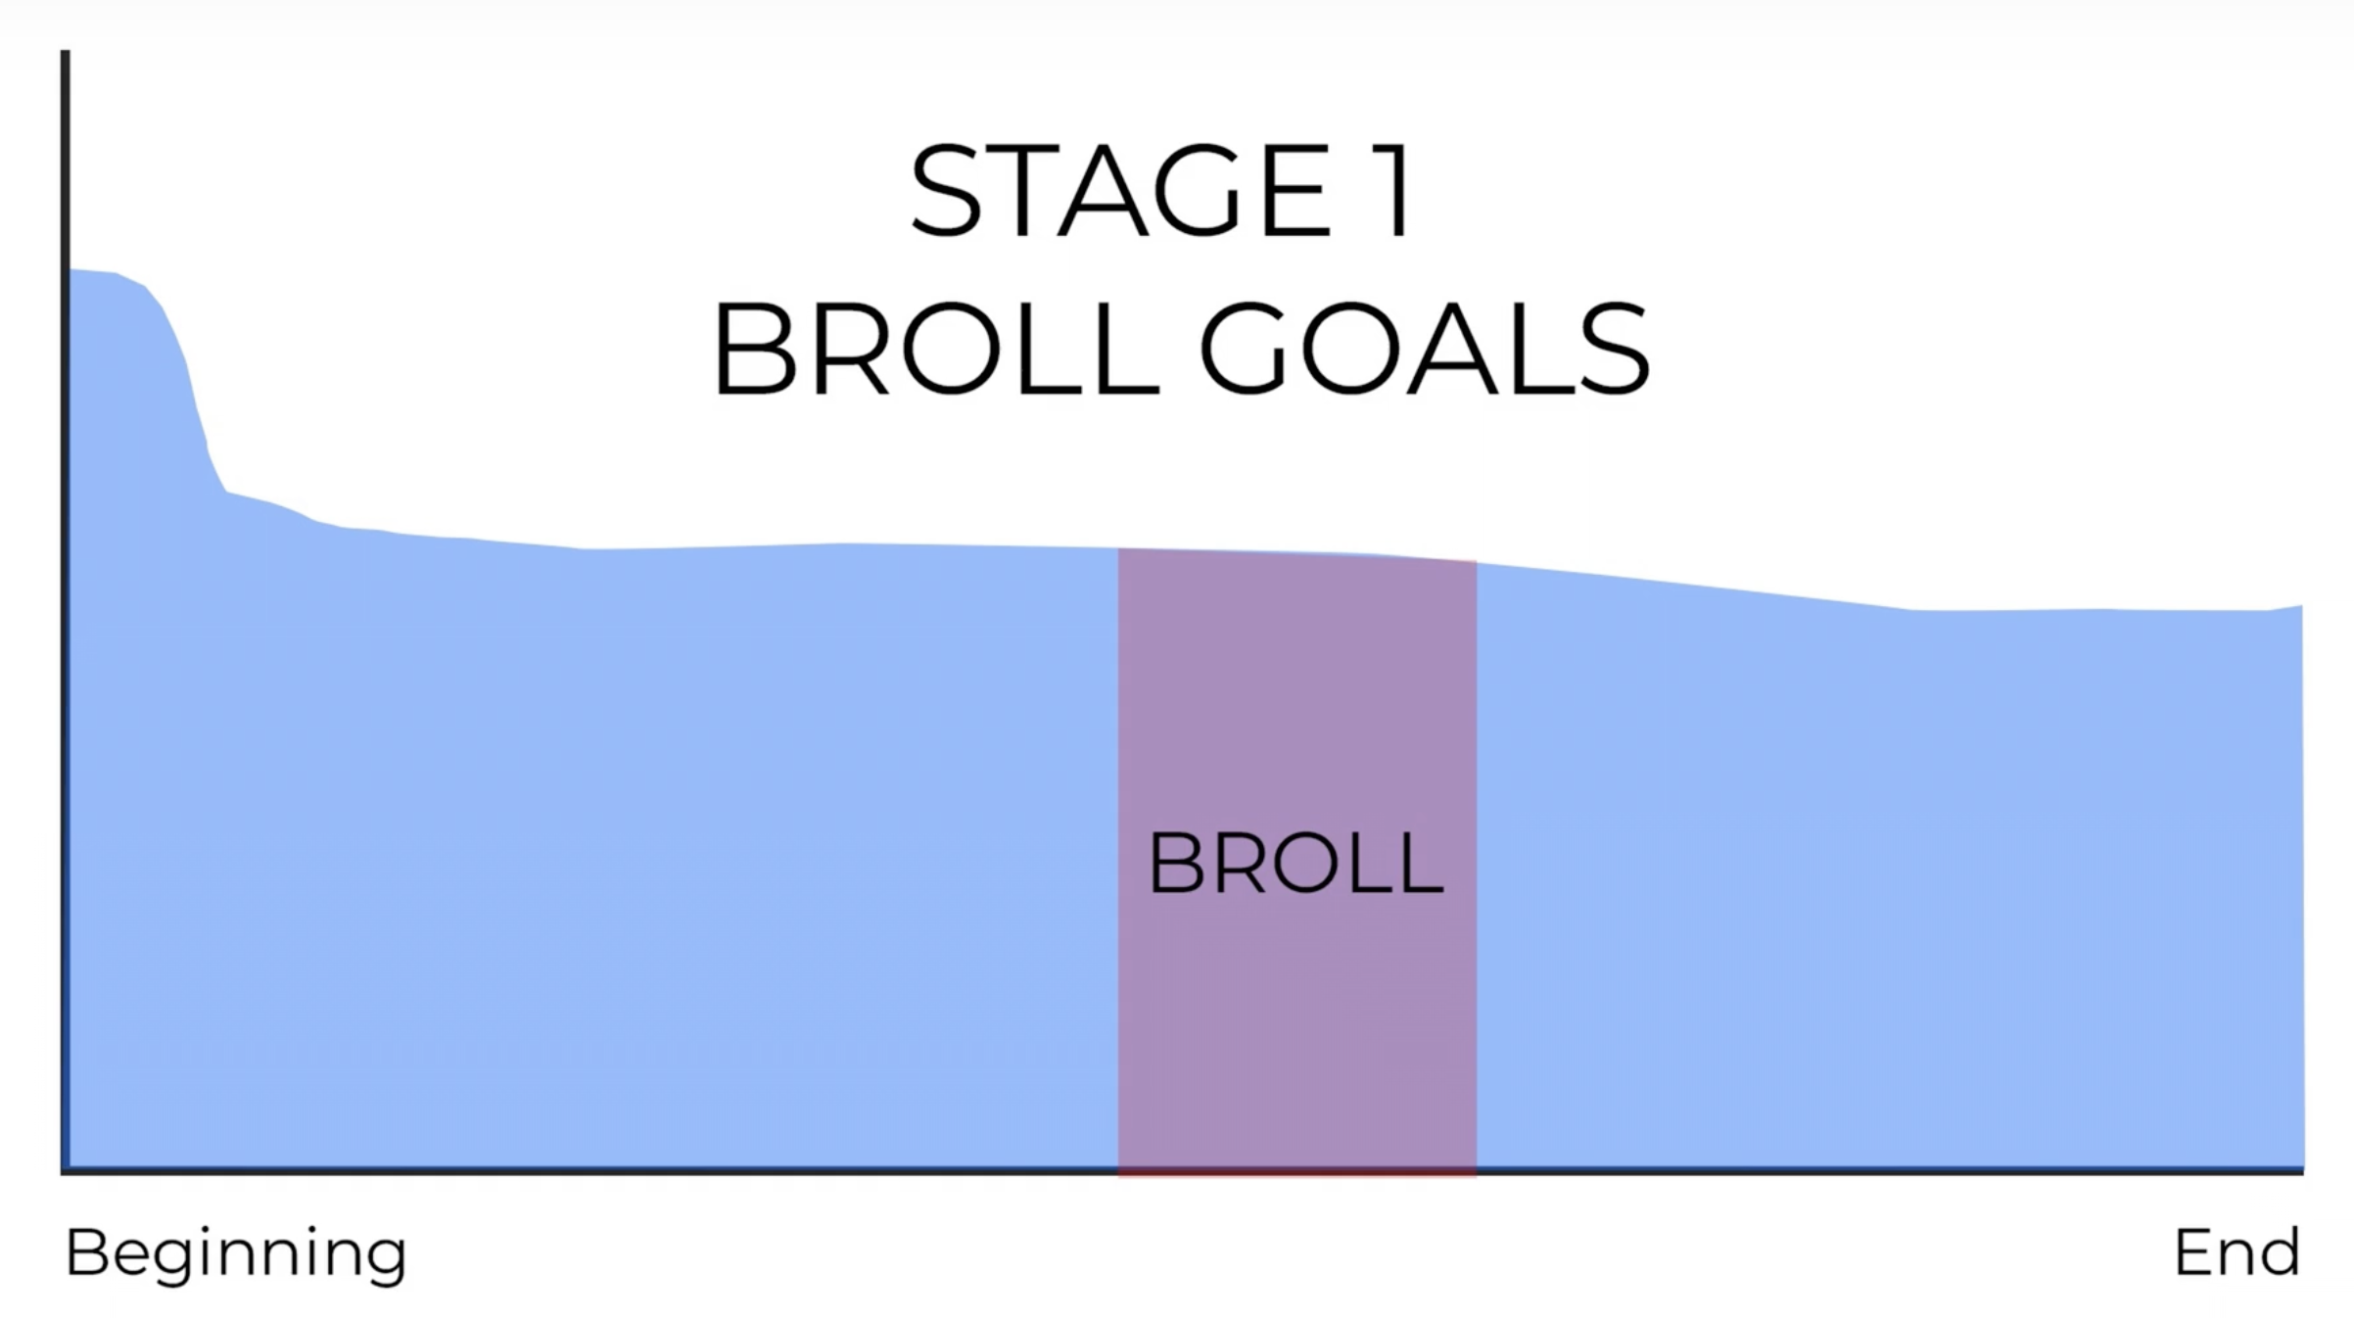
Stage 2: When you have improved, produce videos that use broll to make your intros more engaging.
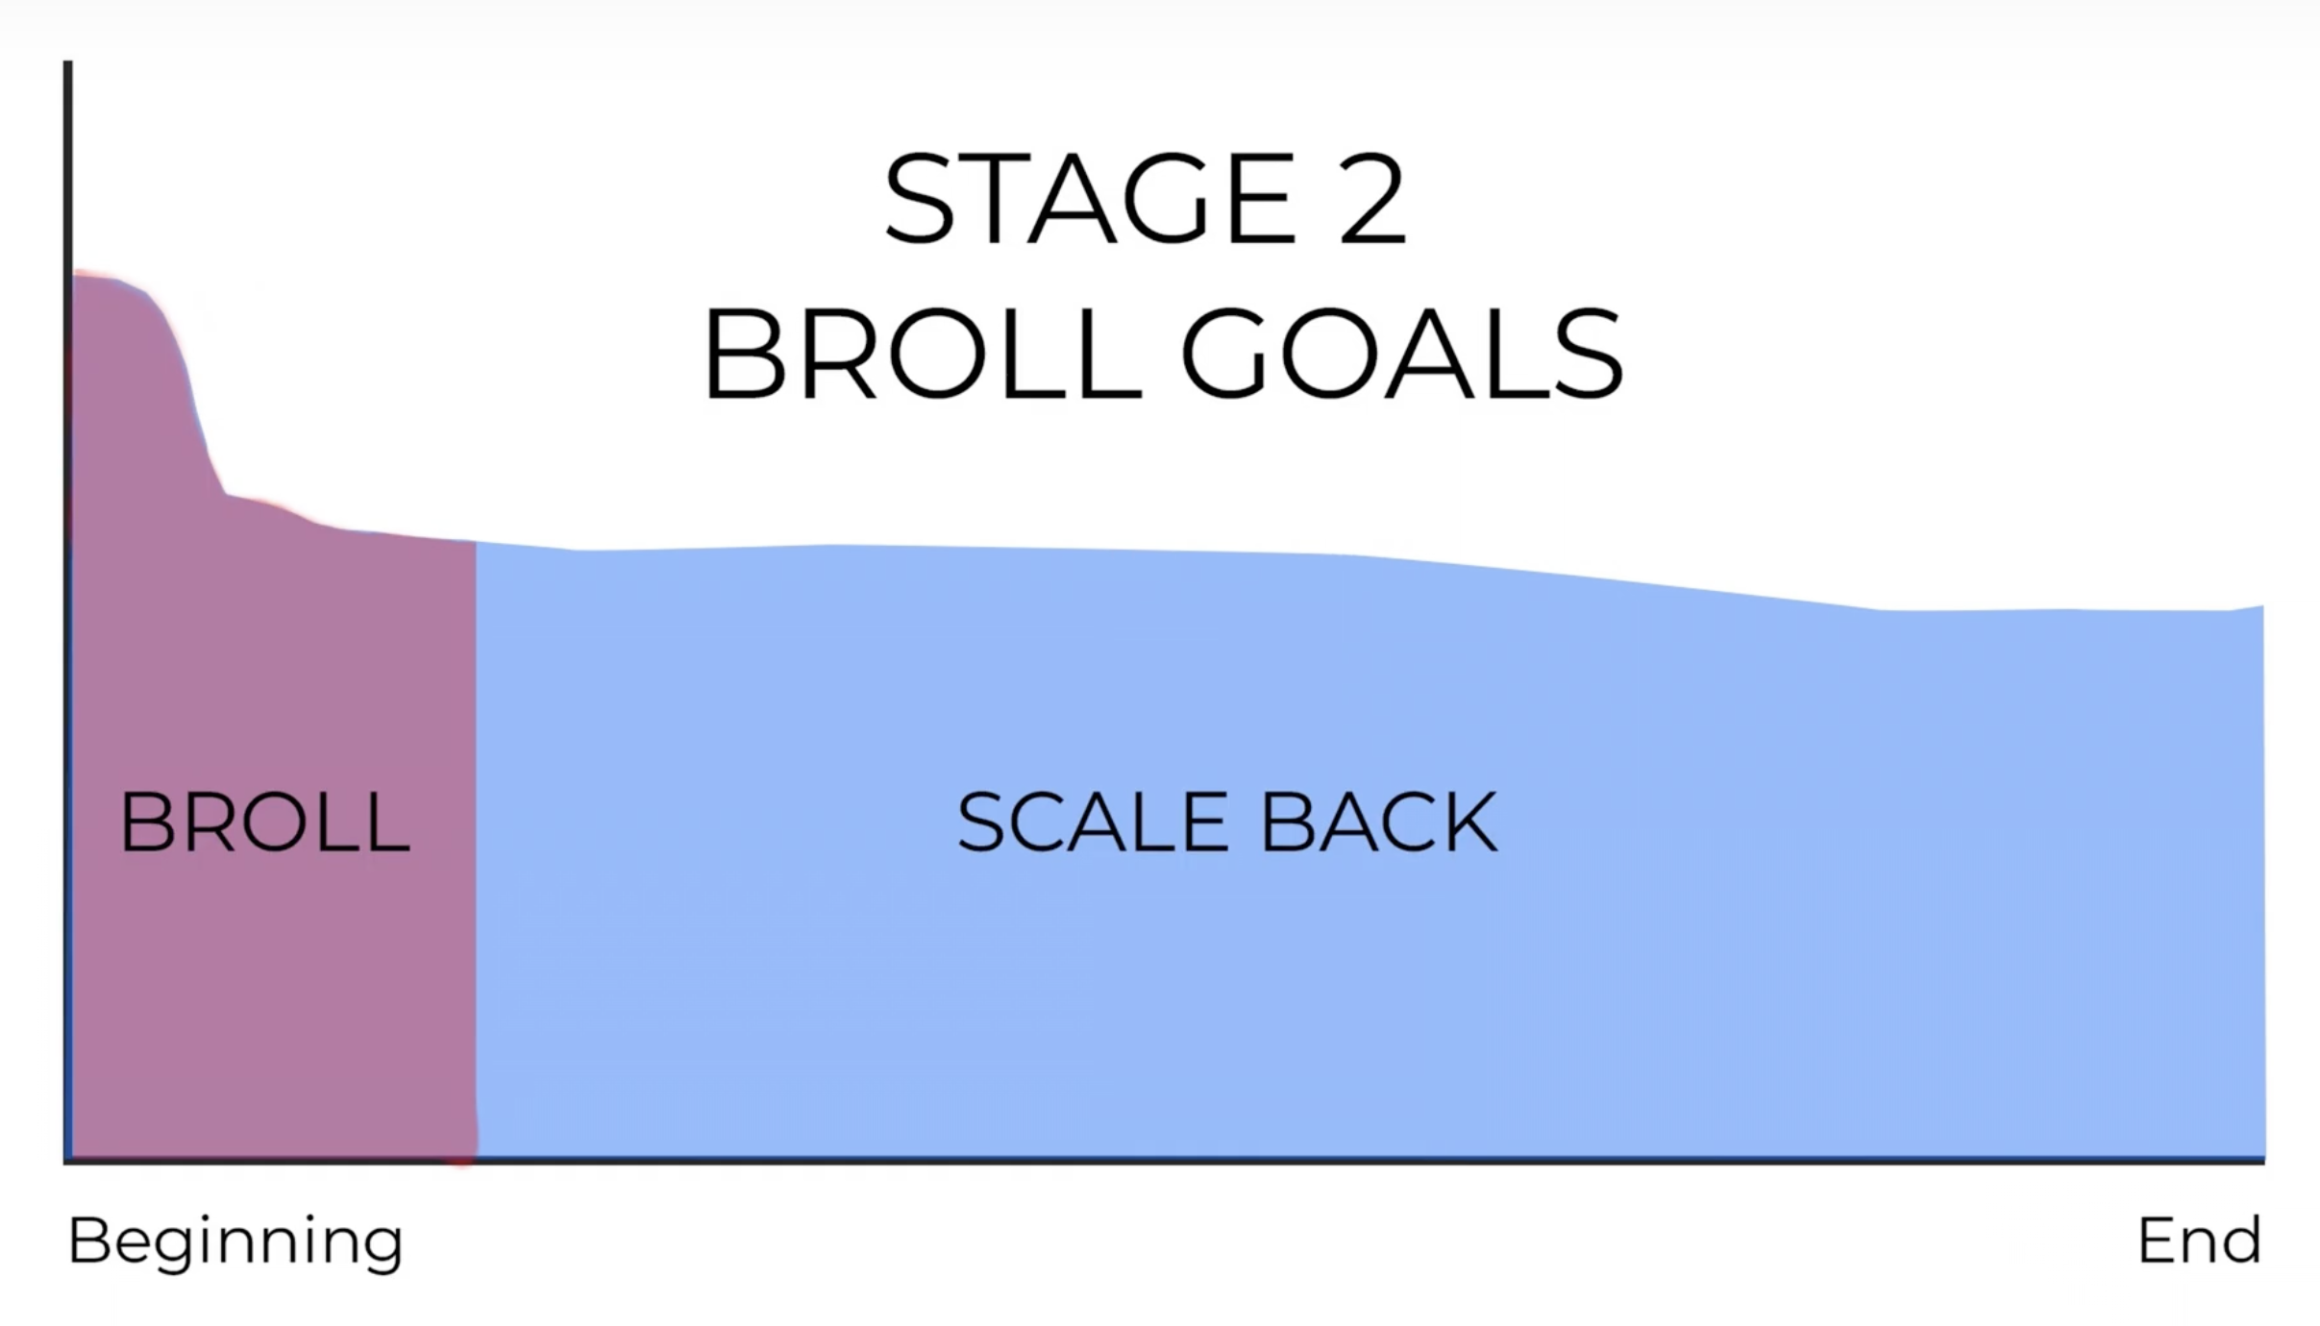
Stage 3: Once you are producing videos faster, seeing results and have more confidence, aim to use b-roll in more sections of your videos to make your points, metaphors and stories more engaging.
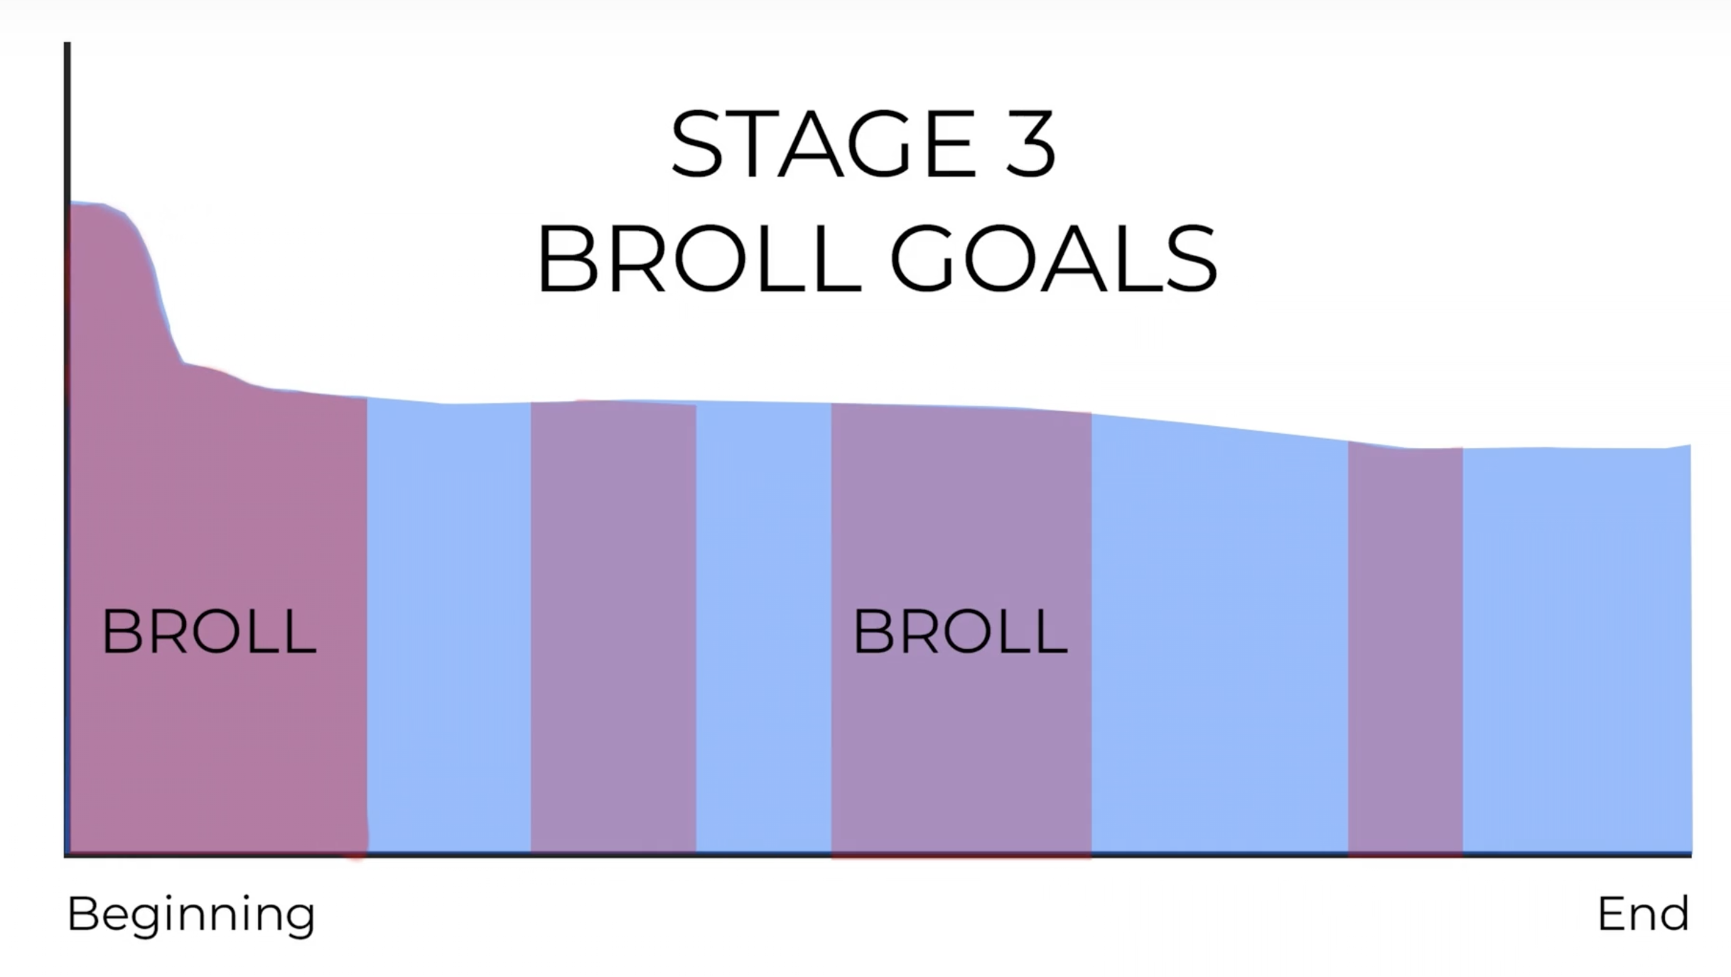
Suggested Order for Skill Building:
Although I know the power of visual storytelling, trying to level up in every area at once is likely to cause you a lot of stress. Here's how I would recommend you build your skills in the same way I did.
1. Scriptwriting: Master the art of writing engaging and entertaining scripts first. This is the backbone of your content; a bad script with beautiful visuals is still a bad video. A great script with no visuals is still a great video.
2. Packaging: Learn to design thumbnails and titles that attract viewers next.
3. Basic B-Roll Integration: Start using simple B-roll in the middle sections of your videos to bring metaphors and stories to life.
4. Advanced B-Roll and Visual Storytelling: Once comfortable, use more complex visual storytelling techniques.
5. Full-Blown Story Video Creation: Create complete story-driven videos for maximum impact.
Should You Even Bother Filming Your Own B-Roll?
We need to consider what the 10x moves are for our channel. Is filming your own B-roll going to help you grow faster?
In some niches, it might not be. Here are some other ways to enhance your visual storytelling without filming your own content.
Use Stock Footage and Images: Leverage stock platforms for high-quality visuals that complement your content.
AI-Generated Visuals: Utilize AI tools to create images or simple animations to illustrate your stories.
Hiring a Videographer: For higher quality and more personalized visuals, consider hiring a professional videographer. It will save you time and energy having someone to help you.

